Project Planning Phase
Project Planning Template (Product Backlog, Sprint Planning, Stories, Story points)

Date | 15 February 2025
Team ID | LTVIP2026TMIDS38821
Project Name | Exploratory Analysis of Rain Fall Data in India for Agriculture
Maximum Marks | 5 Marks

Product Backlog, Sprint Schedule, and Estimation (4 Marks)
Sprint | Functional Requirement (Epic) | User Story Number | User Story / Task | Story Points | Priority | Team Members
Sprint-1 | Data Collection | USN-1 | Gather historical rainfall dataset from reliable source (IMD / Kaggle) | 2 | High | Team
Sprint-1 | Data Collection | USN-2 | Load dataset into Python environment (Pandas) | 1 | High | Team
Sprint-1 | Data Preparation | USN-3 | Handle missing rainfall values | 3 | High | Team
Sprint-1 | Data Preparation | USN-4 | Perform feature engineering (Season, Month encoding) | 3 | Medium | Team
Sprint-1 | Data Preparation | USN-5 | Handle inconsistent and duplicate data | 3 | Medium | Team
Sprint-2 | Data Visualization | USN-6 | Generate Bar Chart (State-wise rainfall) | 2 | Medium | Team
Sprint-2 | Data Visualization | USN-7 | Generate Pie Chart (Season distribution) | 2 | Medium | Team
Sprint-2 | Data Visualization | USN-8 | Generate Line Chart (Year-wise rainfall trend) | 2 | Medium | Team
Sprint-2 | Data Visualization | USN-9 | Generate Correlation Heatmap | 4 | High | Team
Sprint-2 | Model Development | USN-10 | Train ML models (KNN, DT, RF, XGBoost) | 5 | High | Team
Sprint-2 | Web Application | USN-11 | Develop Flask-based web interface | 5 | High | Team

Project Tracker, Velocity & Burndown Chart: (4 Marks)
Sprint | Total Story Points | Duration | Sprint Start Date | Sprint End Date (Planned) | Story Points Completed | Sprint Release Date (Actual)
Sprint-1 | 12 | 7 Days | 01 Feb 2025 | 07 Feb 2025 | 12 | 07 Feb 2025
Sprint-2 | 20 | 7 Days | 08 Feb 2025 | 14 Feb 2025 | 20 | 14 Feb 2025

Velocity:
Total Story Points = 32
Number of Sprints = 2
Velocity per Sprint = 32 / 2 = 16 Story Points per Sprint
Average Velocity per Day (7-day sprint):
16 / 7 ≈ 2.28 Story Points per Day
This indicates a stable and predictable team performance across sprints.
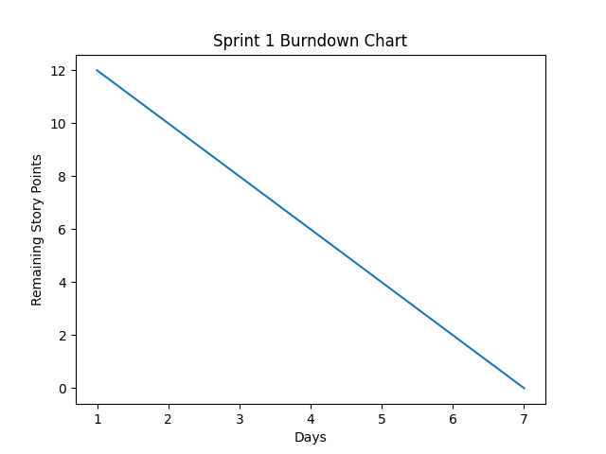
Burndown Chart:
Sprint 1:
- Started with 12 story points
- Gradually reduced daily
- Reached 0 story points by Day

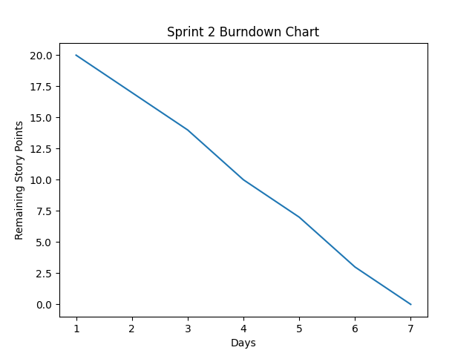
Sprint 2:
- Started with 20 story points
- Consistent daily task completion
- Reduced to 0 story points by Day 7

The steady decline in remaining story points reflects:
- Proper sprint planning
- Realistic estimation
- Efficient execution
- Good team coordination
Reference:
- https://www.atlassian.com/agile/project-management
- https://www.atlassian.com/agile/tutorials/how-to-do-scrum-with-jira-software
- https://www.atlassian.com/agile/tutorials/epics
- https://www.atlassian.com/agile/tutorials/sprints
- https://www.atlassian.com/agile/project-management/estimation
- https://www.atlassian.com/agile/tutorials/burndown-charts
- https://www.visual-paradigm.com/scrum/scrum-burndown-chart/

